

**IOT PROJECT REPORT**

**Topic – Dual-Axis Solar Tracking System** **Using ARDUINO**

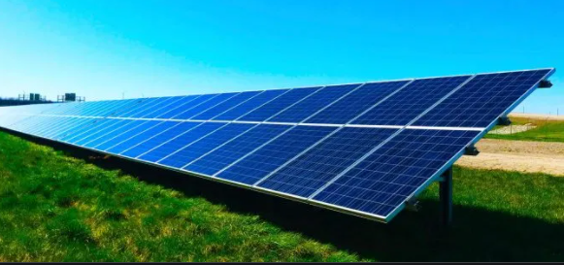

Under the Guidance of **Mr. Sahil Gupta(**mentor**)**

Submitted By **- RAMA CHANDRA SAHU**

College – **NIT ROURKELA**

Summer Internship – May 2021

**Contents**

1. OBJECTIVE

2. INTRODUCTION

3. LIST OF COMPONENTS USED

4. CIRCUIT DIAGRAM

5. COMPONENT DESCRIPTION

6. ALGORITHM FLOWCHART

7. ARDUINO CODE

8. SIMULATION RESULT

9. CONCLUSION

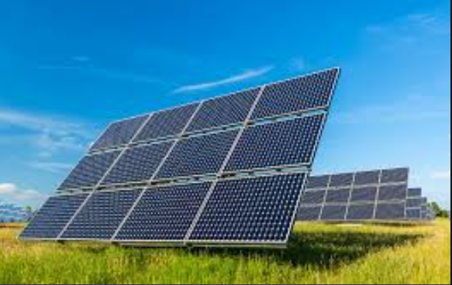

**Objective :**

To Build a High Efficiency Dual-Axis Solar Tracking System using Arduino UNO, LDR Sensors and PWM Servo Motors, The Simulation is done Using Proteus Software and C programming in Arduino IDE

**Introduction**

Renewable energy solutions are becoming popular. As demand is high , Maximizing output from solar system increases efficiency, Presently solar panels are of fixed type which lower the efficiency So the aim is to design the system, which will automatically track the sun’s position and accordingly change the direction of the solar panel to get the maximum output from the solar cell. To implement a solar tracking system which will automatically track sun’s position to increase the efficiency of solar system

**LIST OF COMPONENTS USED**

* Arduino UNO………………………………………………… 01
* LDR…………………………………………….…………………..04
* Solar panel…………………………………………………01
* Resistors …………………………………………………………04
* Motor- PWM Servo………………………………………… 02
* Connecting Wires…………………………………………. As Per Req

**Circuit diagram**

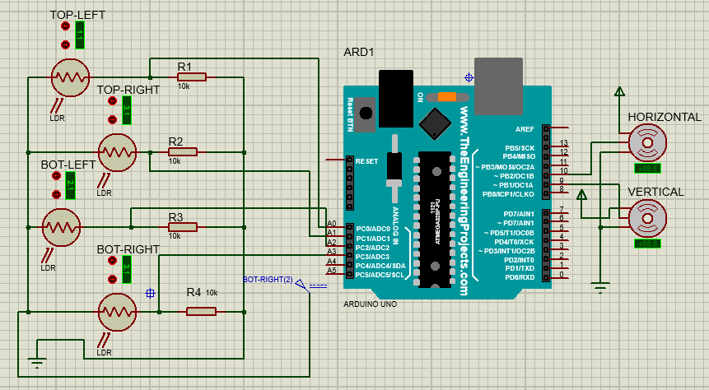

COMPONENT DESCRIPTION

|  |  |
| --- | --- |
| **ARDUINO UNO-**  Arduino is an open-source electronics prototyping platform based on flexible, easy-to-use hardware and software. Arduino can sense the environment by receiving input from a variety of sensors and can affect its surroundings. Arduino projects can be stand-alone, or they can communicate with software running on a computer. In this development, Arduino UNO issued as the main controller because it satisfies these conditions:  • Microcontroller board based on the A Tmega32S.  • 14 digital input/output pins (of which 6 can be used as PWM outputs), 6 analog inputs, a 16 MHz crystal oscillator, a USB connection, a power jack, an ICSP header, and a reset button |  |
| **Solar Panel-**  Solar panels are devices that convert light into electrical energy, they are called "solar" panels because the most powerful source of light available is the sun. A solar panel is a packaged, connected assembly of photovoltaic cells. The solar panel can be used as a component of a larger photovoltaic system to generate and supply electricity in commercial and residential applications. Several types of solar cells available in the market are:  • Monocrystalline silicon (mono-silicon or single silicon)  • Polycrystalline silicon (multi crystalline, multi silicon, ribbon) |  |
| **LDR(Light Dependent Resistor)-**  Photoresistor or light dependent resistor (LDR) is a resistor  which resistance decreases with increasing incident light intensity or exhibits photoconductivity.. The light resistances will drop dramatically when illuminated. |  |
| **Motor - PWM Servo**  **Servos** are controlled by sending an electrical pulse of variable width, or **pulse width modulation** (**PWM**), through the control wire. ... The **PWM** sent to the **motor** determines position of the shaft, and based on the duration of the pulse sent via the control wire; the rotor will turn to the desired position |  |
|  |  |

**Arduino Code**

#include <Servo.h>

//defining Servos

Servo servohori;

int servoh = 20;

int servohLimitHigh = 160;

int servohLimitLow = 0;

Servo servoverti;

int servov = 20;

int servovLimitHigh = 160;

int servovLimitLow = 0;

//Assigning LDRs

int ldrtopl = A0; //top left LDR green

int ldrtopr = A1; //top right LDR yellow

int ldrbotl = A2; // bottom left LDR blue

int ldrbotr = A3; // bottom right LDR orange

void setup ()

{

servohori.attach(10);

servohori.write(20);

servoverti.attach(9);

servoverti.write(20);

pinMode(ldrtopl, INPUT); //define LDR as input

pinMode(ldrtopr, INPUT);

pinMode(ldrbotl, INPUT);

pinMode(ldrbotr, INPUT);

delay(500);

}

void loop()

{

servoh = servohori.read();

servov = servoverti.read();

//capturing analog values of each LDR

int topl = analogRead(ldrtopl);

int topr = analogRead(ldrtopr);

int botl = analogRead(ldrbotl);

int botr = analogRead(ldrbotr);

// calculating average

int avgtop = (topl + topr) / 2; //average of top LDRs

int avgbot = (botl + botr) / 2; //average of bottom LDRs

int avgleft = (topl + botl) / 2; //average of left LDRs

int avgright = (topr + botr) / 2; //average of right LDRs

if (avgtop < avgbot)

{

servoverti.write(servov +1);

if (servov > servovLimitHigh)

{

servov = servovLimitHigh;

}

delay(10);

}

else if (avgbot < avgtop)

{

servoverti.write(servov -1);

if (servov < servovLimitLow)

{

servov = servovLimitLow;

}

delay(10);

}

else

{

servoverti.write(servov);

}

if (avgleft > avgright)

{

servohori.write(servoh +1);

if (servoh > servohLimitHigh)

{

servoh = servohLimitHigh;

}

delay(10);

}

else if (avgright > avgleft)

{

servohori.write(servoh -1);

if (servoh < servohLimitLow)

{

servoh = servohLimitLow;

}

delay(10);

}

else

{

servohori.write(servoh);

}

delay(50);

}

**Simulation Result-**

Case-01

**INPUT** -(avgtop < avgbot & avgleft > avgright) **OUTPUT** -(Horizontal=160 , Vertical 160)

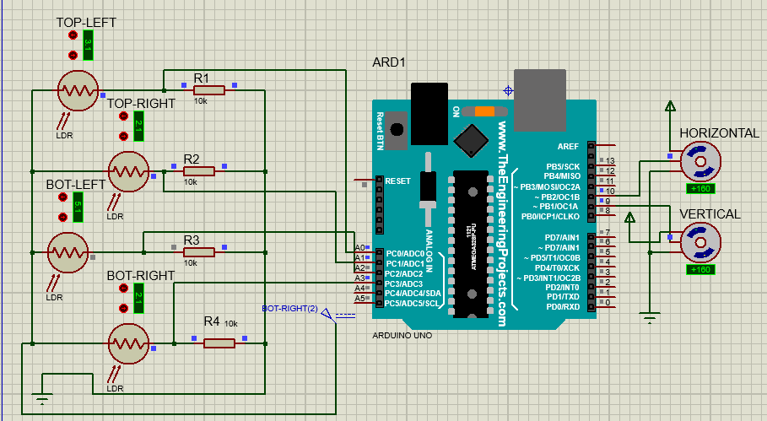

Case-02

**INPUT** -(avgtop < avgbot & avgleft < avgright) **OUTPUT** -(Horizontal=0 , Vertical 160)

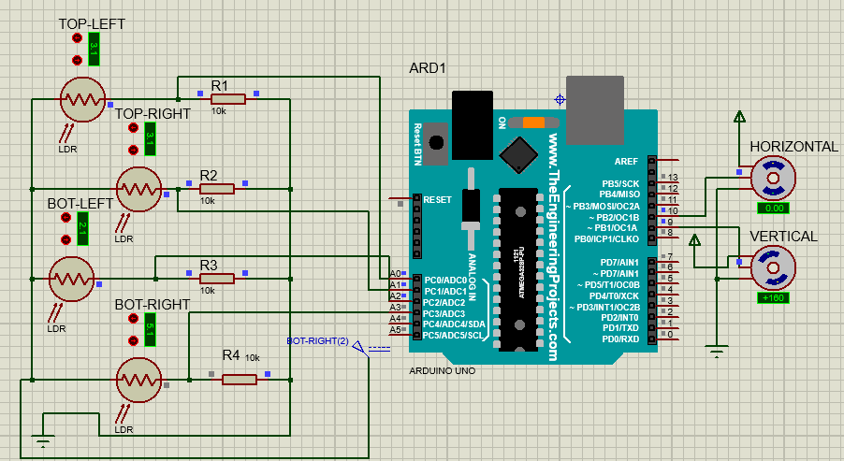

Case-03

**INPUT** -(avgtop > avgbot & avgleft > avgright) **OUTPUT** -(Horizontal=160 , Vertical =0)

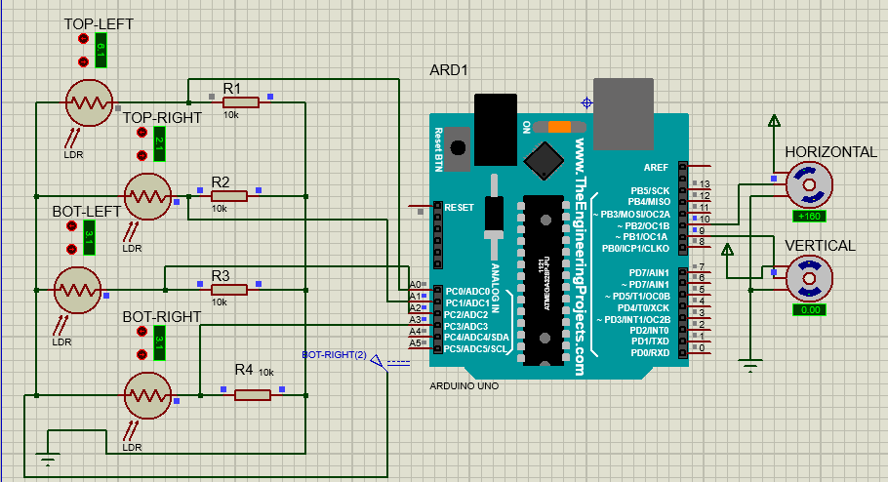

Case-04

**INPUT** -(avgtop > avgbot & avgleft < avgright) **OUTPUT** -(Horizontal=0 , Vertical =0)

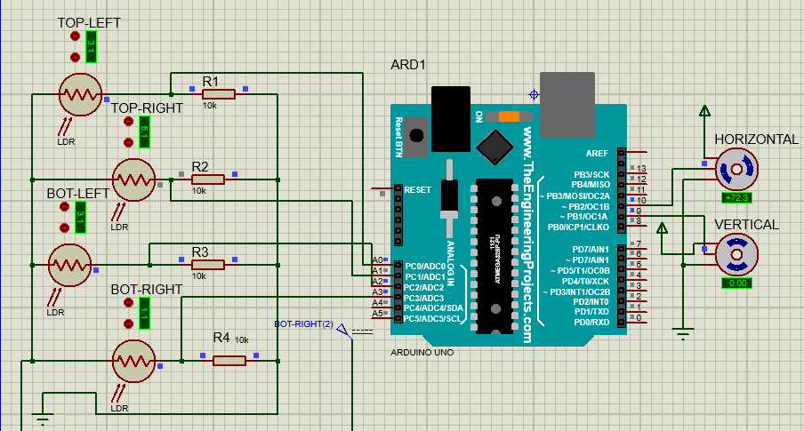

**CONCLUSION-**

The invention of Solar Tracking System helps us improve the performance of PV solar system in a simple way Used relative method of sunlight strength. Established a model of automatic tracking system to keep vertical and horizontal contact between solar panels and sunlight. Improved the utilization rate of solar energy and efficiency of photovoltaic power generation system

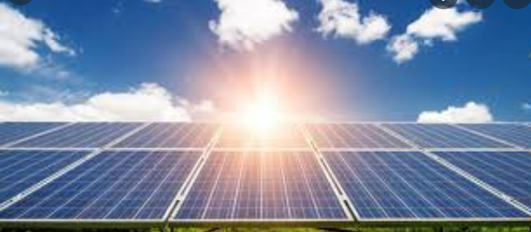

**Thank You**